WEST LONDON WASTE AUTHORITY
Report of the Operations Manager | 20 September 2019
Operations Update

SUMMARY
This report provides an update on the Authority’s operations.

RECOMMENDATION(S)
The Authority is asked to note the information within this report.

- Introduction – This report sets out operations and business plan activities undertaken by the Operations Team. The role of the team is to ensure the day-to-day running of WLWA’s contracts and the operation of the waste transfer station and Household Re-use and Recycling Centre (HRRC) in Brent in line with the Authority’s values of leadership, efficiency, partnership and communication.
- Food waste and green waste – Contractors are coping well with the increased levels of green waste being generated, all contracts are delivering good service levels.
- Transport – Both contracts are currently running smoothly.
- Waste Transfer Stations – Acceptance of waste during the SERC shutdown was managed very well, with no issue of note.
- The project to reduce near misses on these sites has progressed well and seen very positive results. Over 400 site users have had inductions at these sites including borough crews, HRRC drivers and contractor drivers. Monitoring of near misses and infringements on site for May to July has shown a decrease in the number of preventable near misses of 16%.
- On the afternoon Tuesday 27 August a fire broke out at Victoria Road WTS. It originated from bulky material that is shredded to ensure conformance with processing at SERC. The site was closed and the fire brigade attended. The fire was extinguished in a couple of hours and fire watch maintained. Waste from HRRC’s and street cleansing was diverted, in accordance with contingency arrangements, to Hayes and Transport Avenue. The site was available for borough vehicles the following morning.
- Abbey Road Waste Transfer Station (WTS) and HRRC – The construction project to repair the fire damage at the site continues. Scaffolding surrounds the working area around and below where the new concrete has been poured to fill in both compactor holes and re-build the concrete walls that needed to be removed (see pictures).
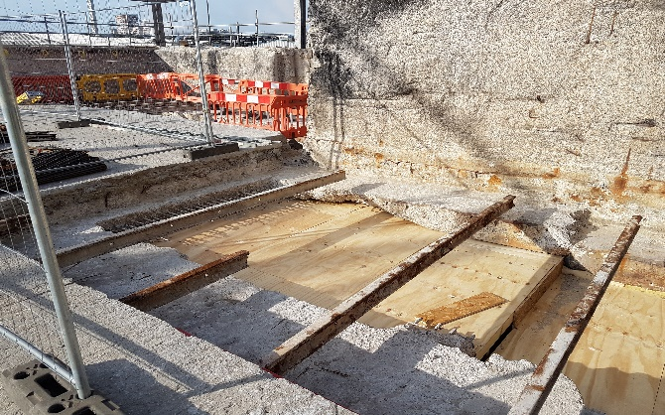
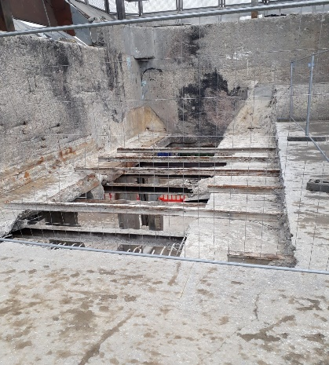
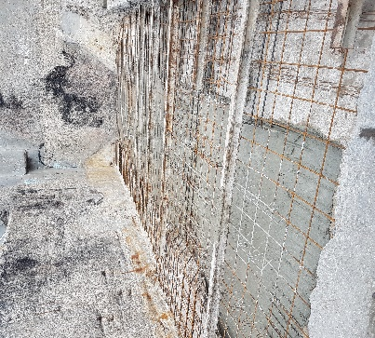
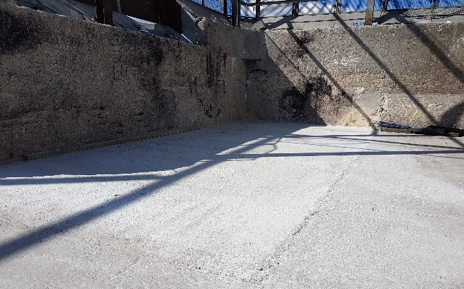
- Just before closing on Tuesday 20 August the waste pile (approximately 50 tonnes) in the WTS caught fire. The site was evacuated in accordance with the fire procedure and the fire brigade attended site in under 10 minutes. The staff worked with the fire service to extinguish the flames and pull waste away from the affected area. The site opened as usual to all customers the following morning. Investigations of the cause are still on-going. The Environment Agency visited the site on the evening of the fire and verbally reported they were happy with the actions they saw.
- The recycling rate for Abbey Road at the end of July was 37%, equal to the performance for last year. The diversion rate is 58%, 1% higher than the same period in 2018.
- Health and Safety – Appendix one shows the progress to date on the health and safety action plan for 2019-20.
- Risk – There are no risks associated with this report.
- Financial Implications – There are no risks associated with this report.
- Staffing implications – There are no staffing implications associated with this report.
- Health and Safety Implications – These are included in the report.
- Legal implications - There are no legal issues arising from this report.
- Impact on Joint Municipal Waste Management Strategy – Operations activities are in line with the following policies:
Policy 6: West London Waste Authority and constituent Boroughs will seek a residual waste management solution in accordance with the waste hierarchy, that presents value for money and that offers reliability in the long term.
Policy 7: The WLWA and constituent boroughs will seek to provide waste management services that offer good value. That provide customer satisfaction and that meet and exceed legislative requirements.
Policy 8: The WLWA and constituent boroughs will work together to achieve the aims of this strategy and are committed to share equitably the costs and rewards of achieving its aims.
Background Papers | None
Contact Officers | Sarah Ellis, Operations Manager 01895 545517  sarahellis@westlondonwaste.gov.uk  Tom Beagan, Senior Contracts Manager 01895 545516  TomBeagan@westlondonwaste.gov.uk

Appendix 1: Health and Safety Action Plan 2019/20 – update September 2019

Ref | Action | Responsible person(s) | Target timescale | Further details | Progress to date
1 | Appoint new H&S Advisor for WLWA | Managing Director | December 2019 | The revised WLWA Health and Safety policy has resulted in the removal of the management appointee role and creation of a Health and Safety Advisor and enhanced health and safety involvement of managers. The new policy document sets out the responsibilities of this role and an external expert needs to be appointed. | The timescale for this has been revised from September to December 2019.  Following review of the existing terms of contract for procurement of services over £20,000, a new set of documents were required. These have now been received and the procurement will begin at the end of September
2 | Develop additional guidance for:  - Provision and Use of Work Equipment (PUWER);  - Electrical Equipment  - Working at Height  - Lifting Equipment and Lifting Operations (LOLER)  - Reporting of accidents, incidents and near misses  in support of the new revised overarching policy document. | Operations Manager | December 2019 | During the revision of the policy and supporting documents the need for these updates was identified. | Until an advisor has been appointed WLWA are procuring an interim solution to get this piece of work underway.  In addition to these guidance documents, officers have identified that further work is required on the driving at work guidance to ensure that driving on the road is discreet from mobile plant operation.
3 | Communicate with all staff so they are informed about the revised document and aware of the contents. | Managing Director | August 2019 | This will be carried out using the new procedure members approved at the June 2019 meeting (appendix 2 to the H&S report). | Toolbox talks have been delivered to all staff. All staff have either been provided with a folder of policies, or directed to the intranet where the files are available.
4 | Make relevant stakeholders aware of the new documentation | Senior Contracts Manager | September 2019 | WLWA will share the documentation with boroughs, contractors, partners etc. | This has begun as part of the regular schedule of contract and borough meetings.
5 | Review all job descriptions to ensure health and safety responsibilities as outlined in the new policy are clearly articulated | Head of Finance and Performance | March 2020 | All existing job descriptions will be reviewed and changes made where appropriate. | This is scheduled to begin later in the year.
6 | Begin developing a positive reporting culture for near misses, accidents, incidents and property damage. | Operations Manager | March 2020 | Work closely with staff to develop their knowledge and understanding of the importance of reporting near misses and accidents to help avoid future injury and ill-health | Work will begin on this later in the year after the new guidance regarding the reporting of accidents, incidents and near misses is complete.
7 | Review head office health and safety arrangements | Head of Finance and Performance | March 2020 | Having moved into a new head office and established activities, it will be useful to take stock of and review the head office health and safety procedures to ensure they are appropriate and suitably embedded. | This is scheduled to begin later in the year.
8 | Encourage shared best practice between all the HRRC and WTS | Operations Manager | March 2020 | WLWA will schedule quarterly HRRC best practice meetings with all boroughs to encourage communication and sharing of information.  The user group meetings for Transport Avenue and Victoria Road will continue quarterly with health and safety being a key item on the agenda including the reporting of incident statistics. | The first meeting was held in April 2019. Meetings will be held in late September, November and February.
9 | Driver induction project for WTS and HRRC’s | Operations Manager | September 2019 | To ensure that the WTS and HRRC a project will be undertaken to ensure that all sites have appropriate inductions and checks in place to ensure that all vehicles (excluding residents in cars) are aware of and follow the site rules to help keep everyone safe on site. | A new induction process is complete for Transport Avenue and Victoria Road. Over 400 site users have had inductions at these sites including borough crews, HRRC drivers and contractor drivers.  Monitoring of near misses and infringements on site for May to July has shown a decrease in the number of preventable near misses of 16%
10 | Develop new staff handbook for Abbey Road HRRC and WTS | Site Manager | March 2020 | There have been a lot of changes and improvements at the site. These need to be compiled together and made quickly and easily available for staff. This will also include wider processes and procedures not just those directly related to health and safety. | Staff have been given a new staff folder containing the new health and safety policy and guidance as well as HR policies.  This will be added to during the year to give them a full range of documents.
11 | New induction for Abbey Road HRRC and WTS visitors and trade waste customers | Site Manager | August 2019 | The current induction will be updated to include new rules and processes being introduced on site. | This is in progress. Due to be completed this month.
12 | Complete the works to repair the fire damage at the Abbey Road waste transfer station and implement all fire risk assessment recommendations. | Site Manager | March 2020 | There are a number of stages to this work, the Site Manager will oversee and co-ordinate the work to keep the site safe and operational throughout the works. | Progress is being made. See main body of the report for the latest detail about the works.
13 | Organise a DSEAR assessment for storage of gas bottles at HRRC sites | Site Manager | September 2019 | This is a new practice being introduced by Suez to their sites across the country. WLWA will adopt this practice and undertake any appropriate actions identified. | This is in progress.

